**VISHWAKARMA INSTITUTE OF TECHNOLOGY, PUNE-37**

**Department of Computer Engineering**



**Project Synopsis**

**ONLINE FOOD ORDERING SYSTEM**

|  |  |  |
| --- | --- | --- |
| **Roll. No.** | **Gr. No.** | **Name** |
| **22** | **11810820** | **Shreya Hirapurkar** |
| **58** | **11810499** | **Vinayak Kokane** |
| **60** | **11810970** | **Dhanraj Kore** |
| **63** | **11920122** | **Vaishnavi Kulkarni** |

**Abstract :**

Our proposed system is an online food ordering system that enables ease for the customers.The online food delivery system is the need of hour because of the recent changes in the industry and the increasing use of the internet. The traditional queueing system drawbacks and disadvantages are overcome by our system application. Food can be ordered online in a hassle-free manner through our proposed system from restaurants as well as mess services. The food order taking methods from customers are improved by our system application. A Food Menu is set up online and as per their wish customers can simply place their order through the proposed system. Also, customers can effortlessly track the orders with a food menu. Users can rate the food items over the feedback system provided by the system.For the payment ,users will have both the options,online and offline.

**Introduction :**

This project will allow hotels and restaurants to increase scope of business by reducing the labor cost involved. The system also allows to quickly and easily manage an online menu which customers can browse and use to place orders with just a few clicks. Restaurant employees then use these orders through an easy to navigate graphical interface for efficient processing. Online ordering system that we are proposing here greatly simplifies the ordering process for both the customer and the restaurant. System presents an interactive and up-to-date menu with all available options in an easy to use manner. Customers can choose one or more items to place an order which will land in the Cart. Customers can view all the order details in the cart before checking out. At the end, the customer gets order confirmation details. Once the order is placed it is entered in the database and retrieved in pretty much real time.

**Aim :**

The aim of this proposed system is to overcome the problems in traditional food ordering system such as-

1.For placing any orders customers have to visit hotels or restaurants to know about food items and then place orders and pay. In this method time and manual work is required.

2.While placing an order over the phone, the customer lacks the physical copy of the menu item, lack of visual confirmation that the order was placed correctly.

3.Every restaurant needs certain employees to take the order over phone or in-person, to offer a rich dining experience and process the payment. In today’s market, labor rates are increasing day by day making it difficult to find employees when needed.

The main advantage of this system is that it greatly simplifies the ordering process for both the customers and the restaurant and also greatly lightens the load on the restaurant’s end, as the entire process of taking orders is automated.

**RESEARCH METHODOLOGY**

The present study is exploratory, and both quantitative and qualitative methods are used for data collection. The study analyzes the responses collected from the restaurants of the Pune city of Maharashtra and attempts to find out the benefits and problems arising in the process. The data is primary in nature and collected with the help of a structured questionnaire comprising both closed-ended and open-ended questions. For the survey purpose, convenient sampling is being used as the sampling method, and the sample size of the study is considered as 25. The research tools used in the study are percentage, Correlation analysis, charts, and descriptive statistics.

**LITERATURE REVIEW**

In [1] an automated food ordering system is proposed which will keep track of user orders smartly. Basically, we have implemented a food ordering system for different types of restaurants in which user will make order or make custom food by one click only. By means of android application for Tablet PCs this system was implemented. The front end was developed using JAVA, Android and at the backend MySQL database was used.

In [2] Customer using a Smartphone is considered as a basic assumption for the system. When the customer approaches the restaurant, the saved order can be confirmed by touching the Smartphone. The list of selected preordered items shall be shown on the kitchen screen, and when confirmed, order slip shall be printed for further order processing. The solution provides an easy and convenient way to select pre-order transaction from customers.

In [3] there was an attempt to design and implementation of digital dining in restaurants using android technology. This system was a basic dynamic database utility system which fetches all information from a centralized database. This application improved the accuracy and efficiency of restaurants as well as human errors. Earlier drawbacks of automated food ordering systems were overcome by this system and it requires a one time investment for gadgets.

In [4] an application of integration of hotel management systems by web services technology is presented. Ordering System Kitchen Order Ticket (KOT), Billing System, Customer Relationship Management system (CRM) are held together by Digital Hotel Management. Add or expand of hotel software system in any size of hotel chains environment was possible with this solution

In [5] along with customer feedback for a restaurant a design and execution of wireless food ordering system was carried out. It enables restaurant owners to setup the system in wireless environment and update menu presentations easily. Smart phone has been integrated in the customizable wireless food ordering system with real-time customer feedback implementation to facilitate real-time communication between restaurant owners and customers.

**Expected Outcome :**

This system will provide customers a way to place an order at a restaurant over the internet and allow hotels and restaurants to increase scope of business by reducing the labor cost involved.All users of the system, are provided with below menu options: Home, Menu, My Cart, User Account, About Us and Contact.

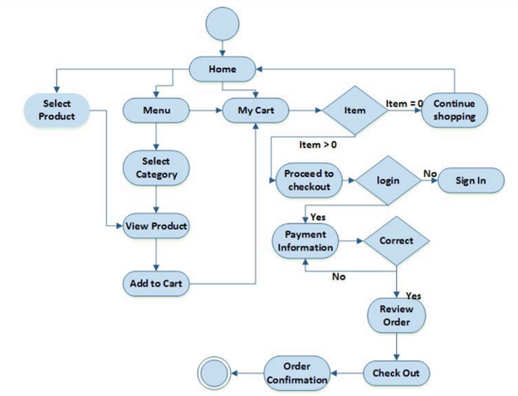

**Data Flow Diagram :**

Level 0 diagram :

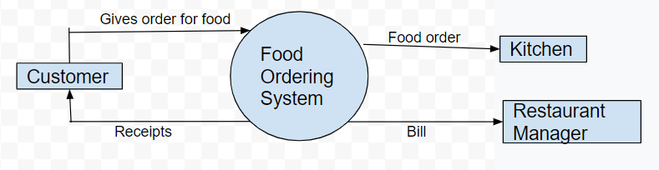

**REFERENCES :**

[1]. Kirti Bhandge, Tejas Shinde, Dheeraj Ingale, Neeraj Solanki, Reshma Totare,”A Proposed System for Touchpad Based Food Ordering System Using Android Application”, International Journal of Advanced Research in Computer Science Technology (IJARCST 2015).

[2]. Varsha Chavan, Priya Jadhav,Snehal Korade,Priyanka Teli, ”Implementing Customizable Online Food Ordering System Using Web Based Application”, International Journal of Innovative Science, Engineering Technology(IJISET) 2015.

[3]. Resham Shinde, Priyanka Thakare, Neha Dhomne, Sushmita Sarkar, ”Design and Implementation of Digital dining in Restaurants using Android”, International Journalof Advance Research in Computer Science and Management Studies 2014.

[4]. Ashutosh Bhargave, Niranjan Jadhav, Apurva Joshi, Prachi Oke, S. R Lahane,“Digital Ordering System for Restaurant Using Android”, International Journal of Scientific and Research Publications 2013.

[5]. Noor Azah Samsudin, Shamsul Kamal Ahmad Khalid, Mohd Fikry Akmal Mohd Kohar, Zulkifli Senin, Mohd Nor Ihkasan,” A customizable wireless food ordering system with real time customer feedback”, IEEE Symposium on Wireless Technology and Applications(ISWTA) 2011